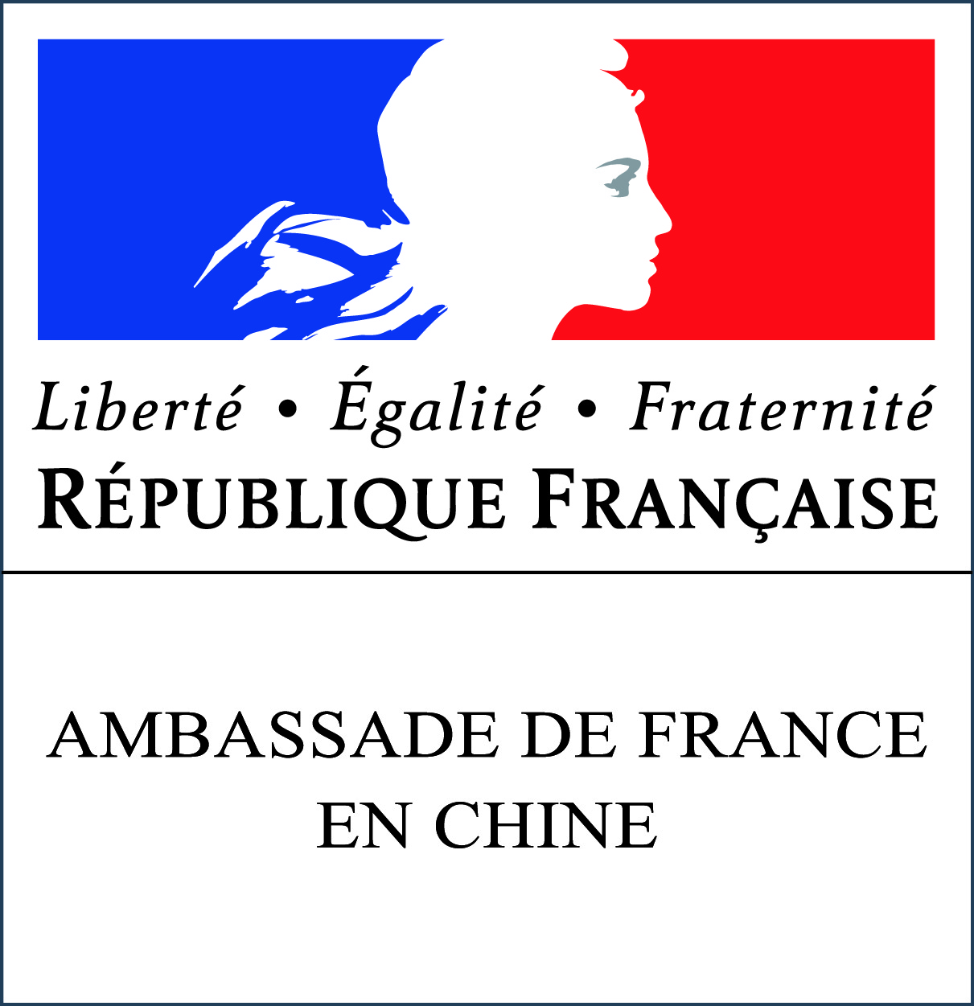

2017

APPLICATION FORM

ÉCOLE D’ÉTÉ FRANCE EXCELLENCE 2017

(Please full fill this application form in ENGLISH)

For which summer school do you want to apply? (Choose one)

- CHEMISTRY:

Sustainable Catalysis: Science and Innovation

Catalysis - ELITECAT CHINA 2017

Advanced Material Sciences

- LIFE SCIENCE:

From unique molecules to cells, from fundamental to applications

Plant Science

Chemistry and biology for medications and health

- MATHEMATICS / INFORMATICS / PHYSICS:

Multispectral imaging for societal, environmental and patrimonial issues

Probabilities and dynamical systems

Mathematical and computational methods for life sciences

Physics for both infinities

- HUMANITIES AND SOCIAL SCIENCES:

Governance and Policy Sciences

Civil Law and Administrative Law in Europe

Tangible and Intangible Cultural Heritage

Cultural Heritage Sciences

PERSONAL DETAILS

Miss Mister
Chinese Name:
Family Name (pinyin):
Given Name (pinyin):
Place of birth:
Phone number:
E-mail address:

ACADEMIC BACKGROUND

Name and place of your current University:
Title of your current Master program:

Year of entrance in the Master program: Expected year of Master graduation:

Please list the courses you studied, in relation with the summer school. Specify your results in these courses.

Benke University (if different): Gaokao result:

Do you plan to apply for a PhD thesis after your Master’s degree? Yes No Do not know yet
Would you like to apply for a PhD thesis in France? Yes No Do not know yet

LANGUAGES

Please specify your language level (Beginner, Elementary, Intermediate, Advanced or Proficient) and any relevant tests that you have taken (IELTS, TOEFL, TOEIC, Cambridge, CET, TEF, TCF, DELF, DALF…)

 | Language | Level | Test name | Test result | Date (yyyy/mm/dd)
1 | English |  |  |  | //
2 |  |  |  |  | //
3 |  |  |  |  | //

MOTIVATION

Please describe your study project and state your reasons for applying to the “École d’été France Excellence” program (motivation, interest…).

Will you participate to this summer school without a grant from the French embassy?
Yes No

ADDITIONNAL INFORMATION

Have you already been awarded a scholarship from the French Government?
Yes No If yes, which one?

How did you hear about the École d’été France Excellence program?
University
Press report
Websites of Campus France or the French Embassy in China
Another way (please specify):

AGREEMENT

I undersigned (Family Name, Given name) , declare that the information is accurate and true. I certify that all documents submitted in support of this application are authentic and I understand that any attempt to obtain scholarship with fraudulent documents will result in cancellation of my application form and will be reported to competent authorities.

Date (yyyy/mm/dd): //

TO APPLY

Please full fill this application form IN ENGLISH and send it as soon as possible by e-mail with required documents to the following address: ecoledete@institutfrancais-chine.com
Please specify in the e-mail field: your name and the name of the summer school you want to apply.

DEADLINE TO APPLY: 26 March 2017 (11:00 pm)

MANDATORY documents to be enclosed to the application form:
- Copy of your current ID card or passport
- Your resume in English (one page)

- If you are applying for the “Catalysis - ELITECAT CHINA 2017” summer school: two recommendation letters

OPTIONAL documents:
- One recommendation letter

Other documents will be required if you are admitted to a summer school:
- A valid language test result
- Copy of your academic transcript and diplomas

More information about the program on: http://www.chine.campusfrance.org/fr/inscription-ecoles-d-ete-2017

